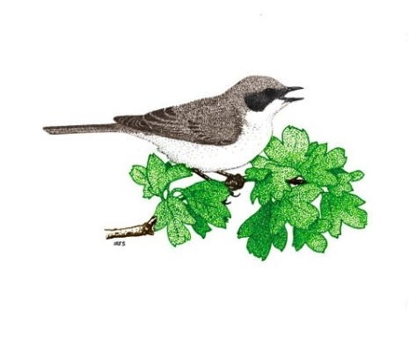
Paisley Natural History Society

Membership application form
I wish to join the Paisley Natural History Society
Title: Mr / Mrs / Ms / Miss (delete as appropriate)
First Name/s: Surname:
Postcode: Phone:
Email address:

I am happy for PNHS to keep my contact details to contact me about PNHS activities* yes / no
(delete as appropriate)
Signature: Date:

Membership fee
Individual membership £15.00
Subscriptions are payable in September each year
Payment by: cash / cheque / direct bank transfer (delete as appropriate)
- Pay by cheque or cash at the September evening meeting (or first meeting you attend)
- Please make cheques payable to Paisley Natural History Society
- For direct transfer email PaisleyNaturalHistorySociety@gmail.com for bank account details

Submitting membership forms:
Print and bring along to the evening meeting, or email to PaisleyNaturalHistorySociety@gmail.com

* PNHS will process your personal data in accordance with Data Protection legislation. This means that confidentiality will be respected and that your details will only be used to contact you about PNHS. You can request to have your details removed at any time by emailing PaisleyNaturalHistorySociety@gmail.com

